AI ASSISTED CODING

ASSIGNMENT-6.5

NAME : K.SAI TEJA
HTNO : 2303A52325
Batch : 35
TASK -1
PROMPT : Generate Python code to check voting eligibility based on age and citizenship
Code :
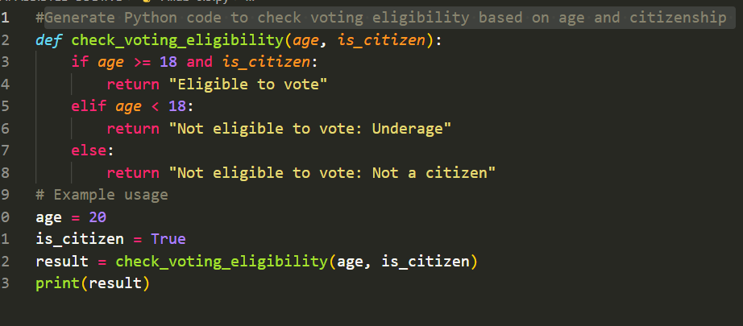
Output:
Explanation :
This code checks whether a person is eligible to vote based on their age and citizenship status. The function check_voting_eligibility takes two inputs: age and is_citizen. If the person is 18 years or older and is a citizen, the function returns that the person is eligible to vote. If the age is less than 18, it returns that the person is not eligible because they are underage. Otherwise, it returns that the person is not eligible because they are not a citizen. In the example given, the age is 20 and the person is a citizen, so the program prints “Eligible to vote.”

Task-2
Prompt : Generate Python code to count vowels and consonants in a string using a loop.
Code :
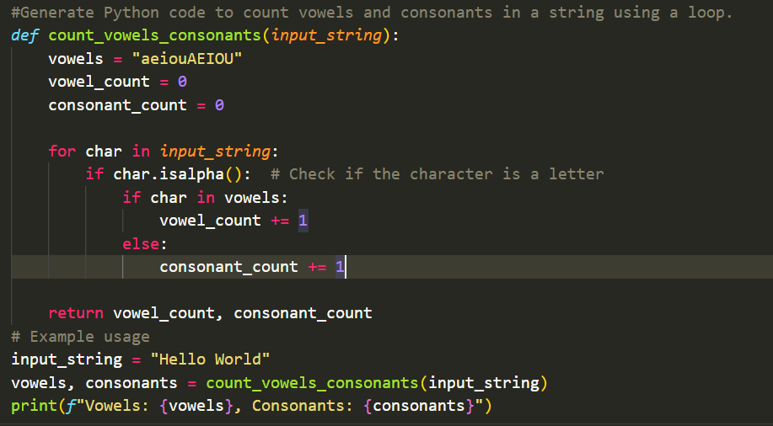
Output:
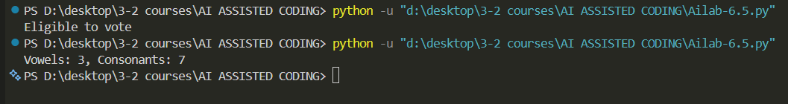
Explanation:
This code counts the number of vowels and consonants in a given string. The function count_vowels_consonants takes one input called input_string. Inside the function, a string vowels is defined containing all lowercase and uppercase vowels, and two variables are used to count vowels and consonants. The program then goes through each character in the input string using a loop. If the character is a letter (checked using isalpha()), it checks whether the character is a vowel or not. If it is a vowel, the vowel count is increased; otherwise, the consonant count is increased. Finally, the function returns both counts. In the example, the input string is "Hello World", so the program prints the number of vowels and consonants in that string.
Task -3
Prompt : Generate a Python program for a library management system using classes, loops, and conditional statements.
Code :
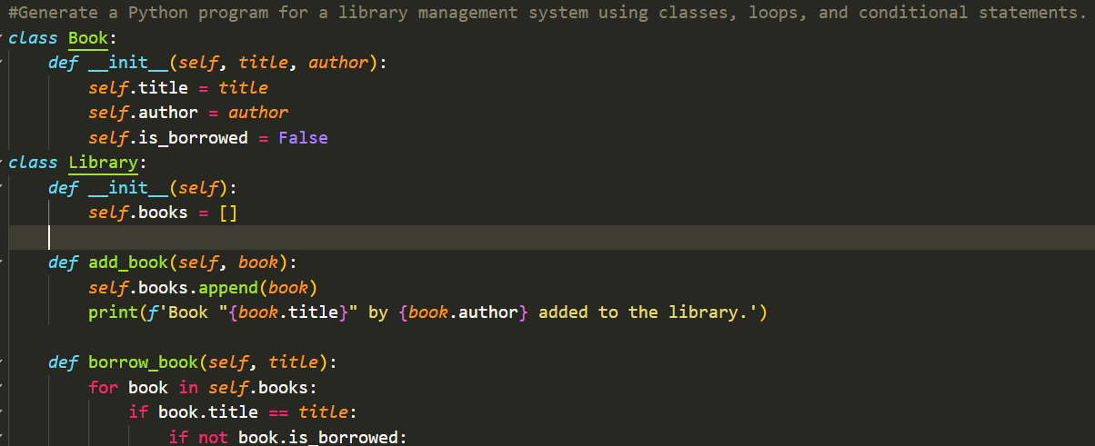
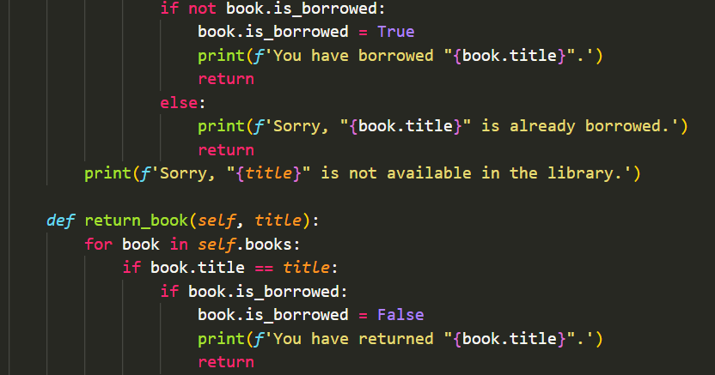
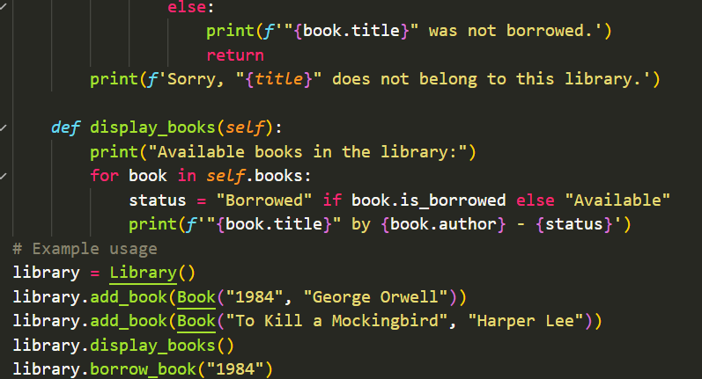
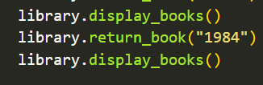
Output :
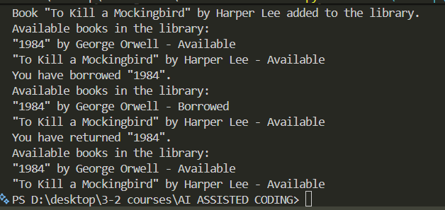
Explanation :
This code creates a simple library system. The Book class stores book details and whether it is borrowed. The Library class manages books by adding, borrowing, returning, and displaying them. In the example, books are added, one book is borrowed and returned, and the library shows the book status after each step.
Task -4
Prompt : Generate a Python class to mark and display student attendance using loops.
Code :
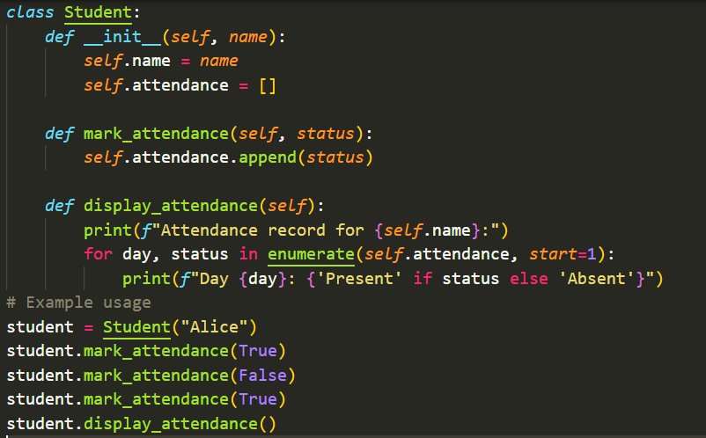
Output :
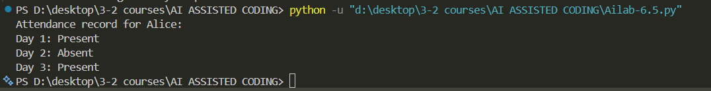
Explanation :
This code manages a student’s attendance. The Student class stores the student’s name and a list of attendance records. The mark_attendance method adds True for present or False for absent to the list. The display_attendance method prints the attendance day by day, showing whether the student was present or absent. In the example, attendance is marked for three days and then displayed for the student Alice.
Task-5
Prompt : Generate a Python program using loops and conditionals to simulate an ATM menu.
Code :
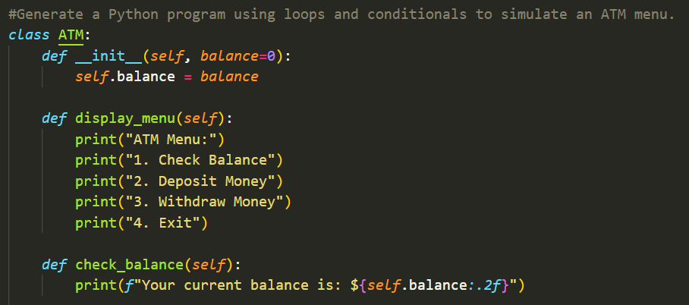
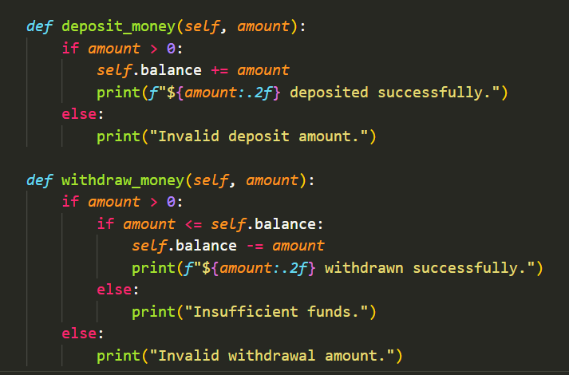
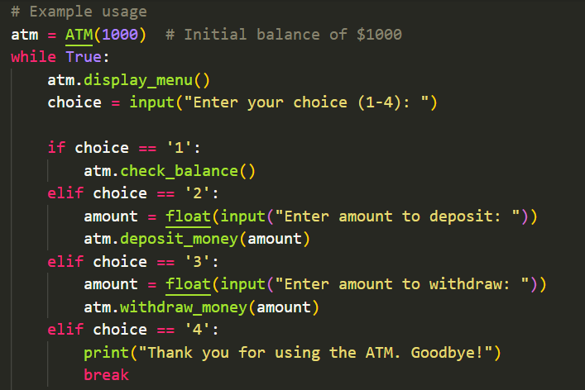
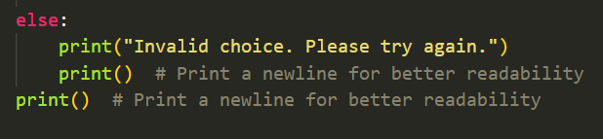
Output :
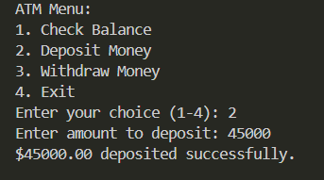
Explanation :
This code simulates a simple ATM system. The ATM class stores the account balance and provides methods to display a menu, check the balance, deposit money, and withdraw money. The deposit method adds money only if the amount is valid, and the withdraw method allows withdrawal only if there are enough funds. In the example, an ATM is created with an initial balance of $1000. A loop repeatedly shows the menu, takes the user’s choice, and performs the selected action until the user chooses to exit.

